You are invited to the installation of
rev. daniel Hough, pastor
little river baptist church
February 18, 2018 4pm
special guests & music, light refreshments
40385 braddock road, aldie, va
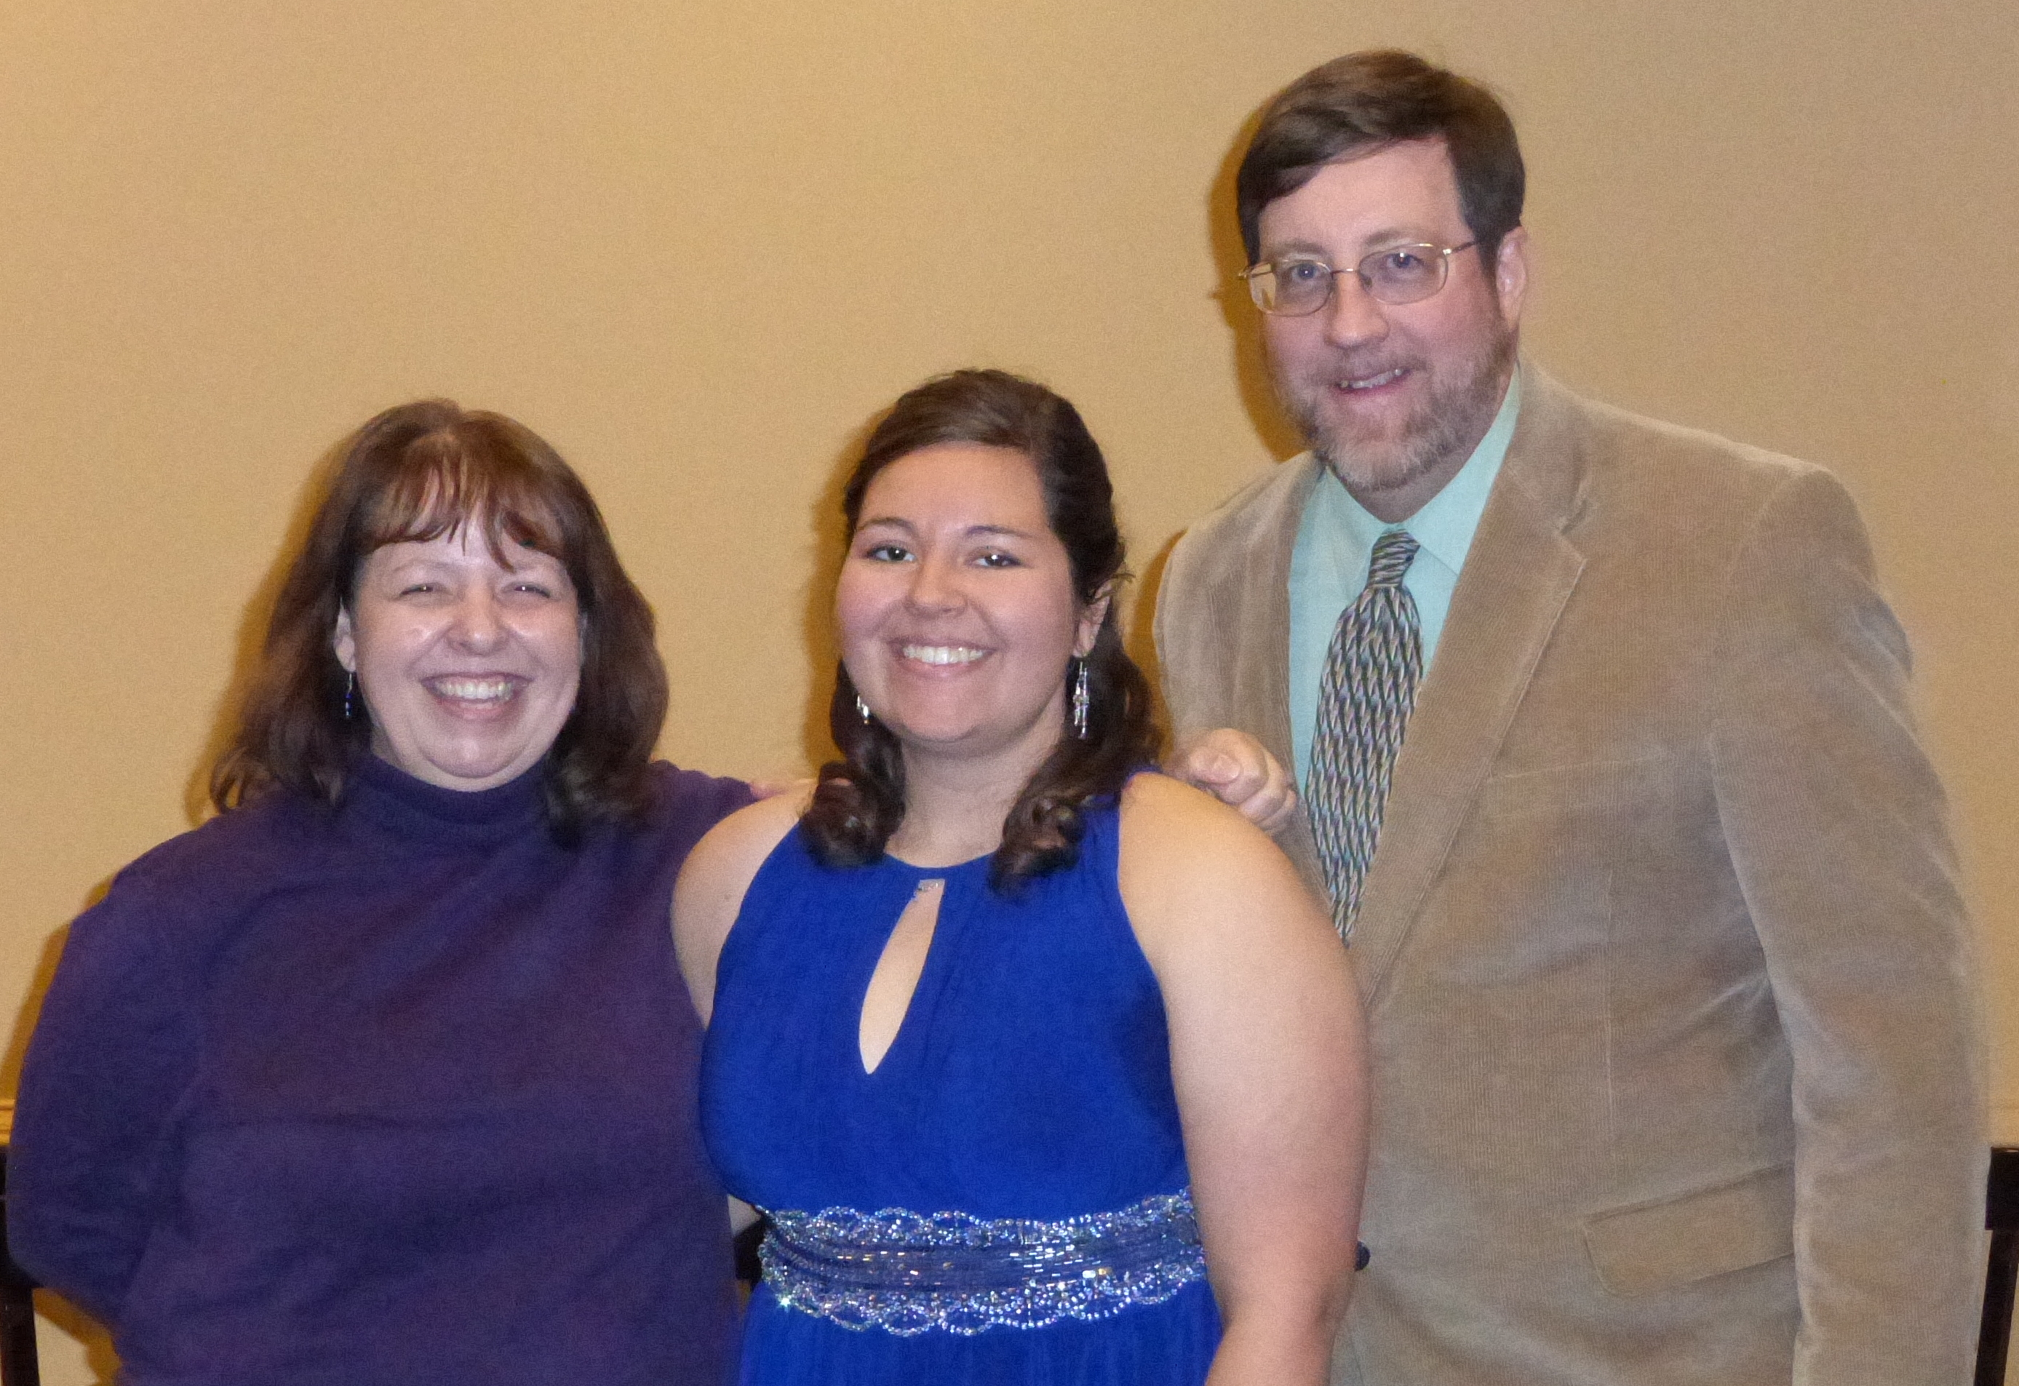
for more information contact: Little river baptist church @ 703-327-4837

